To Create Main Loop, Display Prompt, Read User Input, Handle Exit Conditions, Design Control Flow Diagram, Test Interactive Loop

Code:

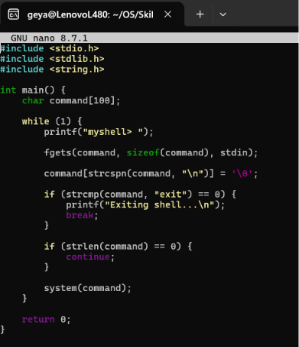
Output:
